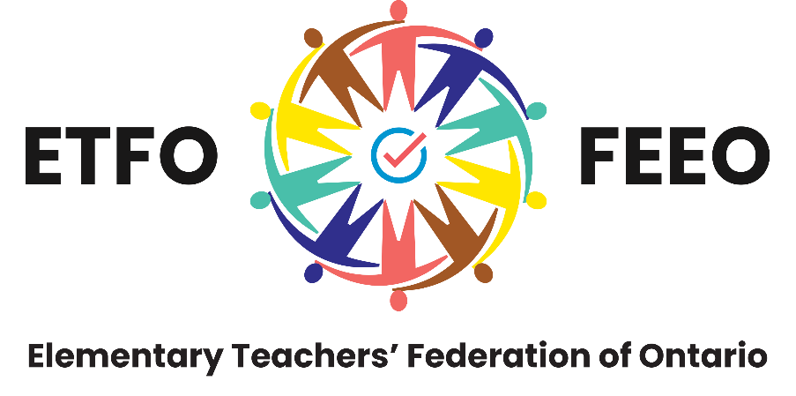

Elementary Teachers’ Federation of Ontario Multi-Year Accessibility Plan

In accordance with Regulation 191/11 Integrated Accessibility Standards

Elementary Teachers’ Federation of Ontario
Fédération des enseignantes et des enseignants de l’élémentaire de l’Ontario 136 Isabella Street, Toronto, Ontario M4Y 0B5
Telephone: 416-962-3836 Toll free: 1-888-838-3836 Fax: 416-642-2424
Website: www.etfo.ca

Table of Contents
Accessibility Plan and Policies for the Elementary Teachers’ Federation of Ontario 1
Statement of Commitment 1
Accessible Emergency Information 1
Training 1
Information and Communications 2
Employment 3
Design of Public Spaces 5
For More Information 5

Accessibility Plan and Policies for the Elementary Teachers’ Federation of Ontario
This 2014-2021 accessibility plan outlines the policies and actions that the Elementary Teachers’ Federation of Ontario (ETFO) will put in place to improve opportunities for people with disabilities.

Statement of Commitment
The Elementary Teachers’ Federation of Ontario is committed to treating all people in a way that allows them to maintain their dignity and independence. We believe in integration and equal opportunity. We are committed to meeting the needs of people with disabilities in a timely manner and will do so by preventing and removing barriers to accessibility and meeting accessibility requirements under the Accessibility for Ontarians with Disabilities Act (AODA).

Accessible Emergency Information
The Elementary Teachers’ Federation of Ontario is committed to providing members with publicly available emergency information in an accessible way upon request. We will also provide employees with disabilities with individualized emergency response information when necessary.

Training
ETFO will provide training to employees, volunteers, and other staff members on Ontario’s accessibility laws and the Ontario Human Rights Code as it relates to people with disabilities. Training will be provided in a way that best suits the duties of employees and volunteers. ETFO does not use volunteers on a regular basis; it is on an episodic basis if needed.
On those occasions when ETFO does use volunteers, they would be sent the link to the training modules that ETFO staff have viewed. They would be asked to view the AODA training modules and then send an email back to the program coordinator noting the date the training was completed. This would be done before they commence their volunteer duties.
The Elementary Teachers’ Federation of Ontario will take the following steps to ensure employees are provided with the training needed to meet Ontario’s accessible laws by January 1, 2015:
- ETFO will provide staff with training in either an online or in-person format. Training will highlight any changes to ETFO policies and procedures as a result of Regulation 191/11.
- Training will be mandatory and notification of training completion will be placed in all ETFO staff files.

- The new ETFO staff orientation process will ensure that all staff that commence employment with ETFO after the initial training has occurred have the opportunity to participate in this training at a future date.

Information and Communications
The Elementary Teachers’ Federation of Ontario is committed to meeting the communication needs of people with disabilities. We will consult with people with disabilities to determine their information and communication needs.
The Elementary Teachers’ Federation of Ontario has taken the following steps to make all new websites and content on those sites conform with WCAG 2.0, Level A by January 1, 2014:
- All new materials posted will be consistent with AODA requirements to comply with WCAG 2.0 level A requirements.
- Ensure ETFO staff that develop materials for the public website are knowledgeable about AODA requirements for documents.
- The requirement specifications of the new Event Management System mandate the vendor to be in compliance with WCAG 2.0 Level AA.
The Elementary Teachers’ Federation of Ontario has taken the following steps to ensure existing feedback processes are accessible to people with disabilities upon request by January 1, 2015:
- ETFO has posted the organization’s Accessible Customer Service Plan which outlines how ETFO provides goods and services to people with disabilities, as well as our feedback process.
- ETFO has provided accessible counters at the reception area.
- ETFO staff trained to provide services compliant with the AODA Customer Service Accessibility Standards for persons with disabilities.
- ETFO staff is investigating the possibility of having a TTY (Teletypewriter) service available.
- Information and training have been provided to staff on the Bell Relay Service.
- Where ETFO responds to feedback received, a written response is developed in a format accessible to persons with disabilities. ETFO staff responsible for the development of responses are trained in the formatting of accessible documents. For verbal response to feedback, ETFO staff is trained to provide services compliant with the AODA Customer Service Accessibility Standards for persons with disabilities.
- Where an accessible format is requested for a feedback response, ETFO staff will consult with the recipient to ensure the accessible format is appropriate.

The Elementary Teachers’ Federation of Ontario will take the following steps to make sure all publicly available information is made accessible upon request by January 1, 2016:
- ETFO’s website will be updated to outline the process for requesting an accessible format and/or communication support.
- Where a request for a public document in an accessible format is received, ETFO shall consult with the individual making the request to confirm the suitability of an accessible format or communication support.
- ETFO shall provide or arrange for the provision of accessible formats and communication support for persons with disabilities in a timely manner and at a cost (where applicable) similarly charged to other persons.
- Regular updates of ETFO’s style guide will reflect accessibility considerations and best practices, where applicable, in the development of documents.
The Elementary Teachers’ Federation of Ontario will take the following steps to make all websites and content conform with WCAG 2.0, Level AA by January 1, 2021:
- ETFO has engaged an outside expert to access the overall accessibility of its websites, web content, and any web-based applications used by ETFO on its public websites to ensure compatibility with WCAG 2.0, level AA.
- ETFO will continue to monitor the development of its web content to ensure compatibility with WCAG 2.0, level AA. Web content will be written in clear language and alternative text for images will be provided, ETFO will also ensure that someone can navigate the website with just a keyboard.

Employment
The Elementary Teachers’ Federation of Ontario is committed to fair and accessible employment practices for its employees.
The Elementary Teachers’ Federation of Ontario will take the following steps to notify the public and staff that when requested, accommodations will be made for people with disabilities during the recruitment and assessment process and when people are hired by January 1, 2016:
- Internal and external postings for employment opportunities at ETFO will reflect ETFO’s commitment to the AODA and the availability of accommodations for applicants with disabilities in the recruitment process.
- ETFO shall offer applicants selected for an interview accommodation, upon request, in relation to the materials and processes to be used. ETFO shall consult with the applicant to provide or arrange for the provision of a suitable accommodation commensurate with their accessibility needs due to disability.
- The employment contract signed between an employee and ETFO will be updated to include ETFO’s commitment to the AODA principles and reference ETFO’s policy for accommodating employees with disabilities.

- ETFO’s Employee Handbook, available to all employees, will be provided to new employees during their orientation session and will be updated to include accommodation policies for employees with disabilities. ETFO employees are advised of changes to the Employee Handbook through internal emails.
The Elementary Teachers’ Federation of Ontario will take the following steps to develop and put in place a process for developing individual accommodation plans and return-to-work policies for employees that have been absent due to a disability:
- Advise all staff about the process and have employees participate in the development of their individual accommodation plan.
- Deal with each request for accommodation on a one-on-one basis and protect the privacy of the employee around workplace accommodations.
- Request an evaluation by an outside medical or other expert to determine if and/or how accommodation can be achieved at the employer’s expense.
- Advise employees that they can ask for the participation of their staff association.
- Ensure that management and employees determine when workplace accommodations should be reviewed and updated.
- Ensure that workplace accommodations are subject to the requirements of the employment standards and the Human Rights Code or else they can be denied.
- Provide the accommodation plan in a format that takes into account the employee’s disability.
- Include the employee’s emergency response information if required in their workplace accommodation plan.
For the development of return-to-work policies, the following steps will be taken:
- Recognize the need for accommodation.
- Gather relevant information and assess needs.
- Write a formal individual accommodation plan.
- Implement, monitor, and review accommodation plans.

ETFO will take the following steps to ensure the accessibility needs of employees with disabilities are taken into account when using performance management, career development, and redeployment processes:
- Review employee’s accommodation plans to understand needs and determine if adjustments need to be made to help them succeed.
- Make performance management documents available in accessible formats when asked.
- Provide feedback and coach employees in a way that is accessible to them.
- When providing career development opportunities and redeployment, consider what accommodations employees with disabilities may need to learn new skills or take on more responsibilities in their current position.

- Determine what the employer can do to help employees with disabilities succeed in other positions at ETFO when they change jobs.
The Elementary Teachers’ Federation of Ontario will take the following steps to prevent and remove other accessibility barriers identified:
- Conduct annual reviews in employment practices or reviews when changes occur that can impact employment practices to ensure accessibility barriers are identified and addressed and develop plans to remove such barriers in accordance with the AODA and the Human Rights Code.

Design of Public Spaces
The Elementary Teachers’ Federation of Ontario will meet the Accessibility Standards for the Design of Public Spaces when building or making major modifications to public spaces.
The Elementary Teachers’ Federation of Ontario will put the following procedures in place to prevent service disruptions to the accessible parts of its public spaces.
In the event of a service disruption, the public will be notified via ETFO’s website and signage will be posted at ETFO’s offices.

For More Information
For more information on this accessibility plan, please contact Vera Chiovitti, Human Resources Officer.
Phone: 1-888-838-3836/1-416-962-3836 ext. 2324
Email: vchiovitti@etfo.org

Accessible formats of this document are available free upon request.

AR:EL:AP:SC

