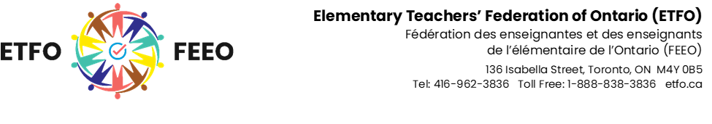

Accessible Customer Service Policy

Providing Goods and Services to People with Disabilities
Elementary Teachers’ Federation of Ontario is committed to excellence in serving all customers including people with disabilities. Our accessible customer service policies are consistent with the principles of independence, dignity, integration and quality of opportunity for people with disabilities.

Assistive Devices
People with disabilities may use their personal assistive devices when accessing our goods, services or facilities.
We will ensure that our staff is trained and familiar with various assistive devices that may be used by customers with disabilities while accessing our goods or services.

Communication
We will communicate with people with disabilities in ways that take into account their disability.
The Elementary Teachers’ Federation of Ontario’s Accessible Customer Service policy is publicly available on our website.

Service Animals
We welcome people with disabilities and their service animals. Service animals are allowed in areas that are open to the public.
When we cannot easily identify that an animal is a service animal, our staff may ask a person to provide documentation from a regulated health professional that confirms the person needs the service animal for reasons relating to their disability.

Support Persons
A person with a disability who is accompanied by a support person will be allowed to have that person accompany them on our premises or at our off site events.
Fees will not be charged for support persons to attend Elementary Teachers’ Federation of Ontario events and conferences. Elementary Teachers’ Federation of Ontario will cover any hotel accommodations or meal costs for the support person.
We will notify customers of this through a notice posted on our premises and through our eNewsletter and website.

Notice of Temporary Disruption
In the event of a planned or unexpected disruption to services or facilities for customers with disabilities held at the Elementary Teachers’ Federation of Ontario provincial offices, reception, staff, and our website will be used to notify customers promptly. This clearly posted notice will include information about the reason for the disruption, its anticipated length of time, and a description of alternative facilities or services, if available.
The notice will be placed at reception by the building entry. Depending on the nature of the disruption, notice will also be provided on outgoing telephone messages and/or on our website.

Training for Staff
Elementary Teachers’ Federation of Ontario will provide training to employees, volunteers, and others who deal with the public or other third parties on their behalf.
Individuals in the following positions will be trained:
- All Elementary Teachers’ Federation of Ontario provincial office staff.
This training will be provided to newly hired staff as part of their orientation to Elementary Teachers’ Federation of Ontario and shall be completed within their probationary period.
Training will include:
- An overview of the Accessibility for Ontarians with Disabilities Act, 2005 and the
requirements of the customer service standard.
- Elementary Teachers’ Federation of Ontario’s plan related to the customer service standard.
- How to interact and communicate with people with various types of disabilities.
- How to interact with people with disabilities who use an assistive device or require the assistance of a service animal or a support person.
- How to use the necessary equipment to provide support to a person with a disability.
- What to do if a person with a disability is having difficulty in accessing Elementary Teachers’ Federation of Ontario’s goods and services.
- Staff will also be trained when changes are made to the plan.

Feedback Process
Customers who wish to provide feedback on the way Elementary Teachers’ Federation of Ontario provides goods and services to people with disabilities can contact the organization by phone, email, or written letter.
All feedback will be directed to the Human Resources Officer.
Customers can expect to hear back in ten business days.
Complaints will be addressed according to our organization’s regular complaint management procedures.

Notice of Availability of Documents
Elementary Teachers’ Federation of Ontario will notify the public that documents related to accessible customer service, are available upon request by posting a notice in the following locations:
- At reception
- Accessible Customer Service Policy
- Website

Modifications to This or Other Policies
Any policy of Elementary Teachers’ Federation of Ontario that does not respect and promote the dignity and independence of people with disabilities will be modified or removed.

